# Paw Points……

# From your Principal

Mrs. Betty Pettiford

j0199709 

**June 1, 2016**

Dear Dogwood Families,

It is with mixed emotions that I write my last letter as Principal of Dogwood Elementary. As many of you have already heard, I am retiring after 41 years in the school system! As I reflect upon the many accomplishments we have achieved over the years, I feel great pride. Our students have participated in county and statewide competitions, receiving numerous awards and recognition. We were recognized from the State Department of Education as Maryland Highest Superlative performing school for our MSA scores in reading and math, and the list goes on.

We want to thank all of the parents who have volunteered, and chaperoned grade level trips, reading, math and STEM nights, attended concerts, talent shows, participated in our Field Day activities, and everyone who supported our school and fundraisers throughout the year. On behalf of our students and staff, Ms. DeDeo and I would like to thank our PTA, business partners and community for their continued support, input, and most of all contributions to Dogwood. Our students succeed because we work together!

Fifth grade parents received information about residency verification prior to spring break. All residency information needs to be submitted to the office by June 30th. To our fifth graders….we know you will continue to make us proud. We thank you for sharing your gifts with Dogwood over the past five years !!!! Please remember to visit us and keep us updated on all of your achievements!!!!

Parents, please mark your calendar. We look forward to seeing you and your parents at some of our end of the year activities. Our Pre-k closing assembly will be held on June 13th , kindergarten on June 14th and our fifth grade farewell assembly will be held on June 15th  in the school cafeteria.

There will be a few staffing changes that will be announced in your August welcome back newsletter. One change to note is that we are excited to announce the name of our new Principal, Ms. Johari Toe. Ms. Toe lives in the community and is looking forward to taking over the reins and continuing to move our school forward.

In closing, I would like to thank you for sending your students to us prepared to learn; and I wish to extend best wishes to all of our students, our dedicated staff, and our families for a safe, happy and healthy summer!

“The object of education is to prepare the young to educate themselves throughout their lives.”

_ Robert Maynard Hutchins

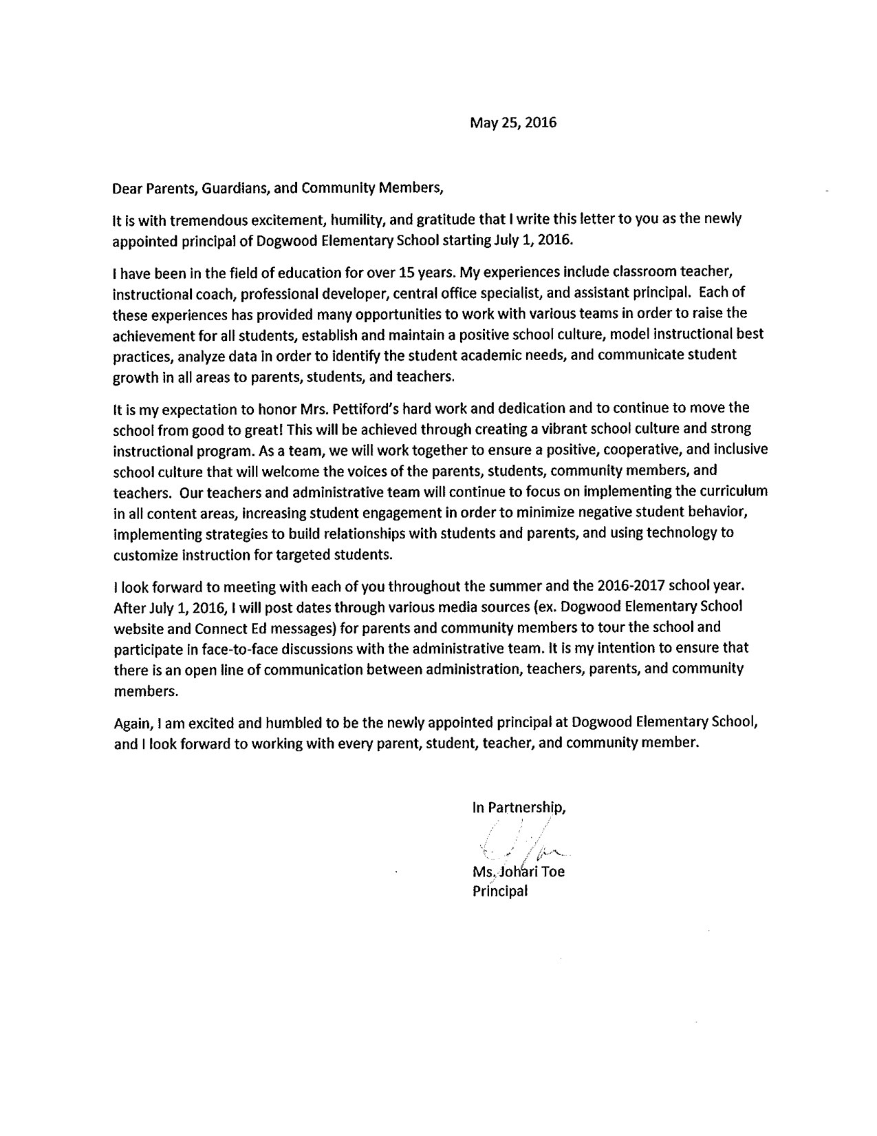

**Dogwood Parent Corner**

Happy June Dogwood Family! We are currently in the homestretch☺. With summer around the corner, prevention of learning loss is key. Let’s keep those minds educationally engaged over the summer while incorporating fun and interactive activities to build upon student academics. Here are a few tips to strengthen your child’s literacy skills at home during the summer:

* Encourage your children to read daily. Ask them to describe what they may see in pictures, as well as describe the story in various stages.
* Read aloud with your child. If they see you reading, they will begin to model your behavior. Kids love the additional interaction and attention from their parents.
* Encourage your children to draw pictures or write a few sentences to describe the book or story they are reading. In addition, discuss their interpretation and provide positive feedback. Ask those ***Who, What, When, Where, and Why*** questions.
* Another engaging activity is to read a book and watch the corresponding video or movie. Have your child compare the similarities and differences.
* Discover what your child is interested and tap into it! Select books and magazines that spark their attention. Whether it’s literature from Maya Angelou, The Wimpy Kid series, comic books, a Pokemon adventure, or a book on dirty bikes, spark their interest! This will make reading appealing, engaging, and not seem like a boring task.
* Literacy can even be developed in the home as well. Describing household tasks as you perform them, or discussing the steps in preparing a meal assist in building vocabulary, sequencing, question and answer, and cause and effect.
* Visit your local library for various literary activities and free resources.
* Utilize BCPS’s Parent University for numerous academic resources. Please visit <http://www.bcps.org/parentu/academics/>.
* Visit Dogwood website for a list of summer learning resources at <http://dogwoodes.bcps.org/>.
* Log into BCPS One under BCPS Digital Content for additional websites and resources.

If you need access to BCPS One before summer break, please contact Mr. Connelly at [nconnelly2@bcps.org](mailto:nconnelly2@bcps.org).

**Don’t forget to follow us on Facebook and Twitter** ☺

***Facebook*:** **Dogwood Elementary School BCPS** 

***Twitter:*** **@Dogwood_ES** 

 **Parent Resources for Summer Learning** 

<http://www.bcps.org/parentu/academics/>

<https://bcpsone.bcps.org/> (Log into BCPS One under Digital Content)

<http://www.readingrockets.org/reading_research_guides_resources>

<http://www.readingrockets.org/article/five-easy-tips-summer-learning>

<http://www.readingrockets.org/article/get-ready-summer-ideas-teachers-share-families>

<http://c.ymcdn.com/sites/www.summerlearning.org/resource/resmgr/GLR/HealthTipsforParents_2015.pdf>

<http://www.colorincolorado.org/article/summer-learning-resources-parents> (Bilingual)

<http://www.pbs.org/parents/education/math/math-tips-for-parents/summer-math/>

<http://www.scholastic.com/parents/resources/article/developing-reading-skills/summer-challenge-101-parents>

<http://www.scholastic.com/ups/campaigns/src-2016>

<http://www.scholastic.com/teachers/collection/keep-kids-reading-all-summer-long>

<https://kids.usa.gov/> (Fun/academic arts & crafts activities)

<http://www.barnesandnoble.com/b/summer-reading/_/N-rs9>

(Students can earn a free book with sign-up)



**Mark Your Calendars**

* Jun. 2nd: **Farewell Music Assembly (9:15am)**

*Students are encourage to wear school colors*

* Jun. 6th: **PTA Meeting (6:00pm)**

*Come meet our new principal Ms. Johari Toe* ☺

* Jun. 7th: **Field Day 2016 (Rescheduled Date)**

*Students please wear clothes to play in, tennis shoes, and sunscreen Parents are encouraged to send in a packed lunch for students*

* Jun. 8th: **4th Grade Field Trip**

*St. Mary’s City*

* Jun. 10th : **5th Grade Field**

*Guide Tour of Historical Philadelphia*

* Jun. 13th: **Pre-K Closing Ceremony (Morning & Afternoon sessions)**

*Morning session: 9:30am*

*Afternoon session: 1:00pm*

* Jun. 14th: **Kindergarten Closing Ceremony**

*Beginning at 9:00am*

* Jun 15th: **5th Grade Closing Ceremony**

*Beginning at 9:00am*

* Jun. 16th: **3hr Early Dismissal for students**

*Students will be dismissed at 12:05pm*

* Jun. 17th: **LAST DAY OF SCHOOL ☺**

*Students will be dismissed 3hrs early (12:05pm pick-up)*

* Jun. 17th: **PTA Night Out at Oriole Park at Camden Yards (7:00pm)**

*For more information, contact the Dogwood PTA at* [*dogwoodpta@gmail.com*](mailto:dogwoodpta@gmail.com)

***HAVE A SAFE AND EXCITING SUMMER!!!***

**Dear Kindergarten Families,**

The sun is shining, the birds are tweeting, and we can't believe that it is ***June*** already! We have had a blast with our students this year and will be savoring our time with them during this last month of the school year. It has been our pleasure to work with your child this year. To our parents, you have been so very kind to us in every way. Thank you so much for all of your enthusiasm in participating in special events with us, and for volunteering for our special kindergarten days, trips, and activities. We appreciate you more than words can say.

The Kindergarten Team,

Mrs. Cumbo, Ms. Sanders, Ms. Sparzak, Mrs. Jackson, and Ms. Halperin

**Helpful June Reminders for You:**

* Please send in a snack **DAILY.**
* Please reinforce all skills taught in class at home. Students should continue to read for fluency, practice sight words, practice counting and identifying numbers, and practice blending exercises, in order to identify unknown works.
* Please note that the Progress Report that you received in May on Conference Day, is your child's final report. There are none issued in Kindergarten for June.
* Please check your child's Take Home Folder daily for important communications from the school.
* Please check your child's backpack for materials that may be sent home that are no longer needed for the school year.
* Please make sure your child has an extra set of **weather appropriate** clothing at the school.

**Important Dates:**

* FIELD DAY-Friday, June 3rd. Fun begins at 9 a.m.
* KINDERGARTEN CLOSING PROGRAM- Tuesday, June 14th at Dogwood Elementary at 9:00 a.m.

***1st Grade News…***

The 2015-2016 Academic School Year is coming to an end! It has been a pleasure watching your child learn and grow this school year. We are very proud of all of their accomplishments. Over the summer, remember to read, write, and practice your math skills. Most importantly, be safe and have fun!!!

We have some fun activities planned for the last days of school. Pizza day on June 10th, Watermelon day on June 13th, beach day on June 14h, celebrate summer birthdays and ice cream day on June 15th, and finally memory books on June 16th . The last day of school is June 17th. The last 2 days of school (16th & 17th) are half days. Thank you to all parents for your assistance and cooperation during the school year.

2nd Grade News… 

Hello Second Grade Families! We are winding down the year and are excited for summer! We are finishing up our Language Arts Unit called Curiosity. We have read texts about astronauts and divers and learned how their curiosity lead to their fascinating careers. In Math, we finished up our unit on fractions and have moved into learning about measurement. The students worked with a variety of units to measure length and distance, including inches, feet, yards, centimeters, and meters.

The students have worked hard all year and we are so proud of them! Please continue to use the BCPSOne resources over the summer and continue reading!! Thank you for all of your support and encouragement this year!

-The Second Grade Team

Ms. Regan- [kregan2@bcps.org](mailto:kregan2@bcps.org)

Ms. Silver- [jsilver@bcps.org](mailto:jsilver@bcps.org)

Ms. Talerico- [mtalerico@bcps.org](mailto:mtalerico@bcps.org)

Ms. Torrence- [atorrence@bcps.org](mailto:atorrence@bcps.org)

Mrs. Weil- [aweil@bcps.org](mailto:aweil@bcps.org)

News from the 3rd Grade 

Welcome to summer 3rd grade families! As our school year comes to a close we are finishing our James and the Giant Peach books as well as Charlie and the Chocolate Factory or Fantastic Mr. Fox! Please continue the excitement over completing a chapter book into the summer with reading every day for at least 20 minutes. Students can also practice writing by writing down what happened in the book they read, any predictions they make or connections they have with the story. In Math we are working on the measurement of both time, distance and weight. You can work on these skills at home as well by asking students the time, how long it takes to get to where you are going or how long it will be an hour or even 30 minutes from now. As you roll into summer please continue to practice those multiplication and division facts! This will prepare students for next year! You can also practice addition and subtracting with regrouping as well as counting money and giving change. We hope you have a fantastic summer and wish you all the best in Fourth Grade!

**Fourth Grade News:** 

As of today – June 3 – we only have TEN SCHOOL DAYS LEFT! And we have a lot do during those 10 days!

* St. Mary’s City Field Trip on Wednesday, June 8. Drop students off between 7:00 and 7:15. Breakfast in the classroom at 7:00; buses load at 7:15; we leave school at 7:30. Don’t be late! Wear comfortable walking shoes; bring a lunch and a towel to sit on the grass for picnicking. There is nowhere to buy lunch in the rural, historic area, so make sure you bring lunch. Dress for the weather.
* We are reading chapter books to end the year. Please make sure you child is doing any assigned reading at home his or her assigned novel. Students cannot participate in discussions and must sit off to the side, catching up on reading, if they do not complete assigned home reading.

Thank you for all of your support this year! It has been a pleasure working with all of the students in fourth grade and we send them on to fifth with pride and confidence that they are ready and will be successful. Have a great summer!

***In 5th Grade News…***

**ACADEMIC RIGOR**

We are almost at the finish line! Students are participating in the health unit. If parents have any questions, please contact your child’s teacher via email.

**Philadelphia!**

Friday, June 10, 2016 7:00 AM - 6:00 PM

Students must report to the school by 7:00 AM. Buses will depart PROMPTLY at 7:30 AM. **NO EXCEPTIONS**!!!

Thank you to all parents who will be assisting the 5th grade team by chaperoning. Please note that this is a **walking tour** and we will cover 4-6 miles over the course of the day.

**Upcoming Year End Events**

* **Fifth Grade Farewell will be hosted Wednesday, June 15th at 9:00am. Students should arrive via their normal mode of transportation.**

SUMMER SCHOOL for soon-to-be 6th graders will be held at middle schools. Invitations will be sent home soon to students who would benefit from attending. Not only will there be academics taught but also, the middle school experience of changing classes and scheduling will be introduced. Please take advantage of this great opportunity.

**NEWS FOR THE SCHOOL HEALTH SUITE**

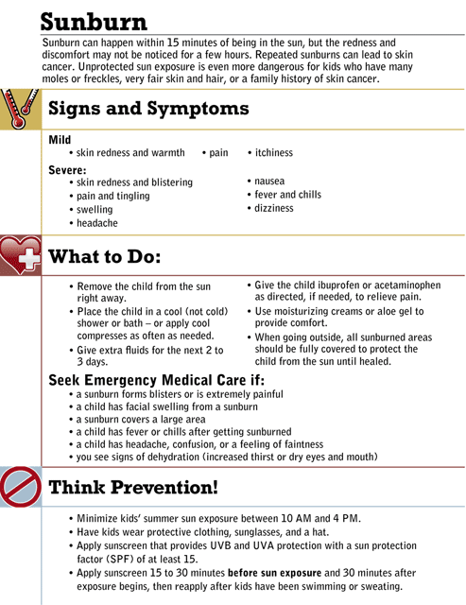

**Drink Up!**

[Drinking water](http://kidshealth.org/kid/stay_healthy/food/water.html) is an important part of staying healthy, especially when it's hot outside. When you're [sweating](http://kidshealth.org/kid/talk/yucky/sweat.html), you [lose water](http://kidshealth.org/kid/stay_healthy/fit/dehydration.html) that your body needs to work properly. And if you're playing a sport or running around in the sun, you lose even more water, because you sweat that much more. Cool down with water.

**Protect Your Brain—Wear a proper fitting helmet when biking, skating, or on a scooter /skateboard**.

*Have a happy, healthy, and safe summer! Mrs. Edwards, RN*

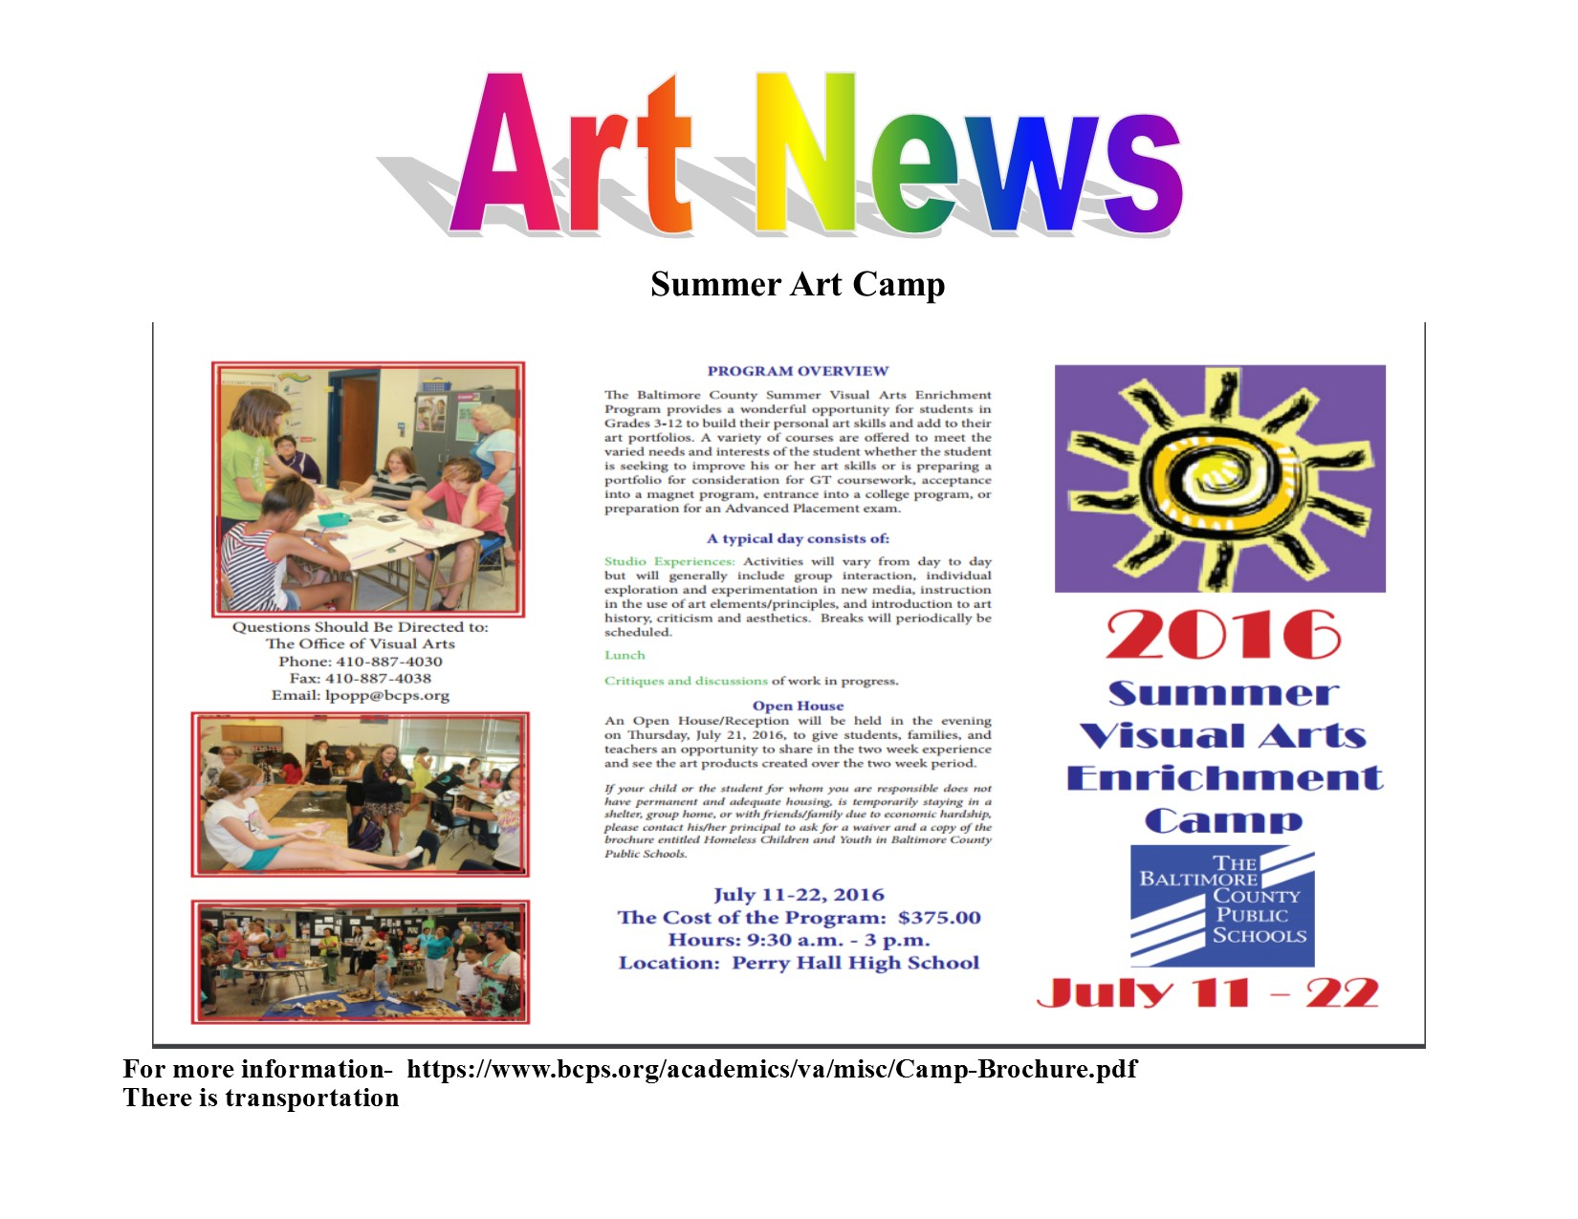

LIBRARY NEWS!!!

Summer Checkout has begun, all books checked out after June 6th are due back in September. They can be returned early at any time by bringing them into the school office during the summer.

SUMMER HOURS!!!!

July 12th and 13th the Library will be open from noon to 3

Make your own stop motion movie of a fable!

Learn to code computers!

Story time and Book Checkout!!!!!!!

**PTA PAW PRINTS**

**What a year it has been! The PTA would like to extend their gratitude to the Parents, Faculty and Staff who have supported all of our programs and fundraisers this year.**

**As we enter our final days of the school year, please join us in allowing your child to participate in our upcoming PTA Spirit Days!**

**Wednesday 6/8/16- Orioles day**

**Thursday 6/9/16- Crazy sock day**

**Friday 6/10/16- Favorite Disney character / superhero day (NO costumes) Monday 6/13/16- Backwards day Tuesday 6/14/16- Crazy hat day Wednesday 6/15/16 Hawaiian/ Luau day**

**We hope to see all Paws on Deck at our final PTA meeting to be held Monday, June 6, 2016 and meet Dogwood's incoming Principal.**

**For those who purchased tickets to the Orioles game, we will see you on the 17th!**

**Have a safe and relaxing summer😎**

**The Dogwood PTA**