STUDENT SUPPLIES:
- 3 packs (at least) of #2 wooden pencils – no mechanical
- 2 packs of crayons – no markers or colored pencils
- 2 highlighters
- 1 pair of kid-sized scissors
- 3 marble composition notebooks (wide ruled)
- 1 pencil pouch
- 2 glue sticks
- 2 packs of wide ruled lined paper
- 1 pack of 5 tab binder dividers
- 1 one inch binder – D Ring preferred
- 8 colored pocket folders
  - 2 red
  - 2 blue
  - 2 green
  - 2 yellow
- 1 pack black dry erase markers – no colors please
OPTIONAL BUT HIGHLY RECOMMENDED
- Personal ear-bud headphones

PLEASE FEEL FREE TO DONATE ANY OF THE FOLLOWING SUPPLIES:
- Liquid hand soap
- Hand sanitizer
- Paper towels
- Boxes of tissues
- Packs of stickers
- Zip-lock bags
- Packs of #2 pencils

We look forward to seeing you!
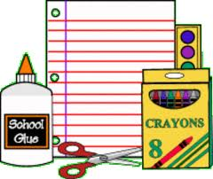
- Third Grade Team

